Changing the Record.
FRED ARCHER
By Sarah Goodenough
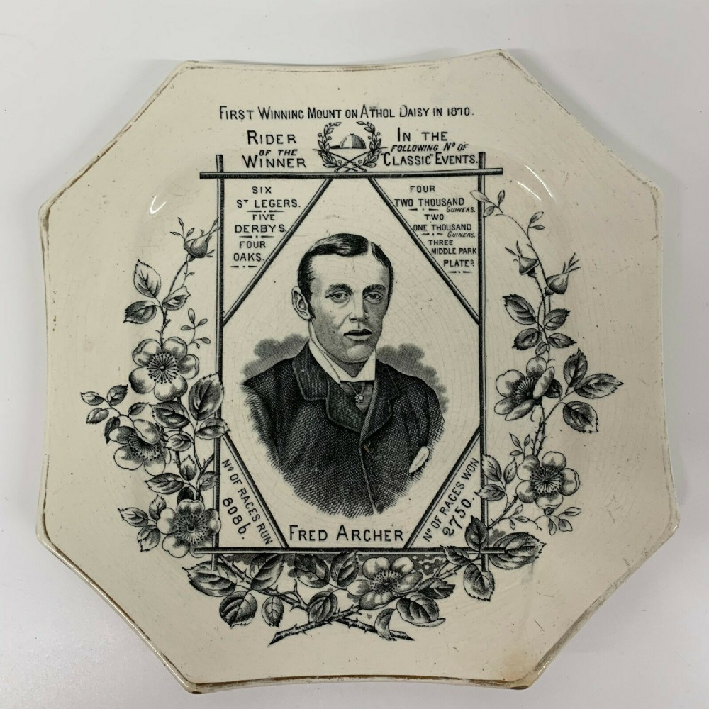

Introduction.
Underneath a strong spotlight an old, octagonal ceramic plate is displayed behind a large glass wall. It’s easily overlooked amongst the other larger and brighter memorabilia arranged in the museum cabinet.
A smartly dressed young man’s face looks straight at you, surrounded by numerical figures and names. The words “winner,” “winning,” and “won” suggest the subject is of a competitive nature; whilst “mount,” “races” and “rider” hint at horsemanship. His name seems almost an afterthought, squeezed beneath the illustration in capital letters; the hard numerical facts seem to be of more importance. A bloom of monochromatic dog roses surrounds the information on show. The plate has been in the DANUM museum collection since 1997 and was produced by Wallis Gimson and Co. of Staffordshire in the 19th century.
Fred Archer was a jockey who won 2,750 races out of 8086 in just over 14 years, a remarkable achievement considering that is nearly 200 wins each year. But it was all over when he died at the young age of 29 in 1886. Archer didn’t have the typical Victorian diseases like consumption or cholera; it was far more shocking.
He put a gun to his head and fired…

Starting Post.
Frederick James Archer was born in a small cottage just off St George’s Place in Cheltenham on the 11th January 1857. His father William was a steeplechase rider who wed local beauty Emma Hayward in 1849. Together they had three sons and two daughters and settled in the quaint village of Prestbury two miles from Cheltenham.
William encouraged young Fred to ride horses rather than concentrate on a school education, much to his mother’s chagrin. Natural talent along with his father’s riding connections secured eleven-year-old Fred a five-year apprenticeship at Heath House, the home of racehorse trainer Mathew Dawson in Newmarket. It marked the beginning of an extraordinary career.
Handsome, clever, and reserved Fred was a favourite with the Dawson family and swiftly moved up to the ranks of stable jockey with his first major win at the Cesarewitch Handicap, a race held at Newmarket, in 1872. The triumphs soon added up with a grand total of nine Classic victories under his belt by the end of the 1870s. In 1877 Fred won the prestigious St Leger race for the first time on a horse called Silvio.

The St Leger at Doncaster.
Since the sixteenth century people have attended race meetings in Doncaster and they have continued to grow in popularity, “…there was a race-course on the Town Moor at the very beginning of the seventeenth century…” (Fletcher, p37). In 1849 the railway connected Doncaster to London with race days generating huge profits for the Great Northern Railway (GNR) company.
The St Leger Stakes is the final of the Five Classic races which are held annually across the UK. It was established in 1776, the name being chosen over a dinner party at the Red Lion Inn; a building that still exists and is now a Wetherspoons branded pub in Doncaster centre. Anthony St Leger (1731-1786) was MP for Grimsby and lived near Doncaster; born in Ireland he was also a successful Lieutenant General in the British Army. The idea came about whilst discussing a sweepstake to be held locally with his friend Charles Watson-Wentworth (the second Marquess of Rockingham and twice Prime Minister of Great Britain) who was hosting the party:
“…with the assistance of (Watson-Wentworth), he established a two-mile race for three-year-old horses, on the Cantley Common…This was to become the St Leger Stakes.” (Tuffrey, p93)
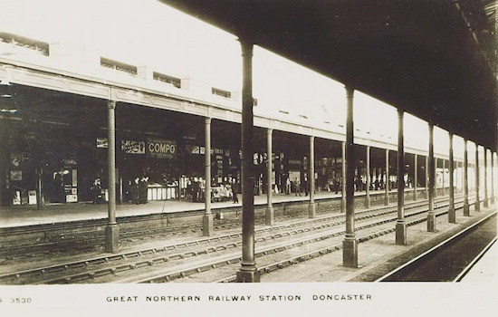
Fred would travel by steam train to the various racecourses around the UK.

Every September, Doncaster becomes packed with excited racegoers arriving to celebrate the Betfred St Leger Festival- “Doncaster has long been regarded as one of the finest racecourses in Europe and the best place for horse racing in Yorkshire” (source Doncaster Racecourse official website, accessed February 2024.) In the foyer of Doncaster Racecourse there is a striking “St Leger Roll of Honour” displayed on the wall where Fred’s name appears six times along with the winning horse, year and trainer. He celebrated success at Doncaster in 1877, 1878, 1881, 1882, 1885 and 1886.

A Jockey and his Health.
Fred was very tall for a jockey with sources suggesting he was between 5ft 8in and 5ft 10in. “He was so tall, and for a man of his weight to ride 8 stone 7lb. required a great effort” (Humphris, p248); these figures when entered online into the NHS Body Mass Index calculator give a reading of very low 17/18 in the Underweight Category; concerning enough to warrant professional help immediately.
A newspaper article in The Maidenhead Advertiser from August 1882 described him as presenting “a rather painful appearance. Imagine a tall emaciated-looking man, cadaverous of countenance…round shoulders and long somewhat misshapen legs.” Not exactly the image of a fit and healthy sportsman you would expect. The same article tells us “…he breakfasts off a couple of Seidlitz powders…and has been known to positively fill himself with drugs.” These laxative powders were available in the 19th century often bringing about very unpleasant side effects after mixing with water.
Nearly every day Fred battled with keeping his weight down so he could enter races where the actual weight allowances were meticulously governed by strict rules. He resorted to extremely drastic measures that are almost barbaric in nature. Exercise was out of the question as he didn’t want to gain weight in muscle. Fred would sit in a Turkish bath for hours, sweating any excess pounds off yet becoming severely dehydrated; he even had one built at his home “consisting of two rooms, one for sweating, the other for shampooing and a douche.”
Saunas were used by jockeys at racecourses up until their permanent ban in 2021 by the British Horseracing Authority. This has stirred up controversy as the Professional Jockeys Association are highly concerned that more detrimental ways will be used instead, causing even greater harm. Hot baths, diuretics, appetite suppressants, even vomiting are just some of the other hazardous alternatives jockeys will use.
Another way Fred was able to keep the weight off was to use an extremely strong laxative known as “Archer’s Mixture” created for him by his own doctor. The exact recipe is unknown but one formula from Graham’s Modern Domestic Medicine for a “purgative…that will operate very quickly and powerfully” consists of Epsom Salt, Glauber’s Salt, Spearmint Water, Tincture of Senna and Antimonial Wine (antimony being a semi-metal that is almost as toxic as arsenic).
Fred also took castor oil as a laxative; long-term use causes loss of electrolytes and vital nutrients, the body eventually becoming malnourished. He was known to be put off by the sight of solid food; one biography states: “His breakfast was a tablespoon of castor oil and half an orange, his lunch a sardine and a small glass of champagne” (Welcome, p35).
Even nowadays jockeys rarely touch food for up to 24 hours before racing. This kind of crash dieting leads to bulimia and osteoporosis. Many medical experts are now calling for the weight limits to be increased due to the harm caused by excessive weight loss methods.

Love and Loss.
“Poor Nellie! She was my glory, my pride, my life, my all, and she was taken from me…” said Fred, confiding in a friend on the death of his wife.
Some years earlier, the scene around Newmarket church was one of celebration, happiness, and unheard of over flowing crowds when Fred finally married in January 1883. Helen (Nellie) Rose Dawson was a petite brunette born in 1861 to John and Grace Dawson. John’s brother was the trainer Mathew who had employed Fred in his youth. After the perfect wedding and honeymoon the couple settled at Falmouth House; Fred had the home built several months earlier with his earnings and named it after his patron Lord Falmouth.
After Fred’s death there was an auction which sold all the “valuable furniture and effects” which gives us a glimpse of the interiors. It was most lavishly filled with walnut, oak and mahogany pieces, velvet pile curtains and rugs, silver, and China ornaments. There was a well-stocked cellar full of expensive champagne like Bollinger and Moet & Chandon; a tennis court and the walls were adorned with beautiful paintings of his winning mounts. It was the ultimate Victorian dwelling.
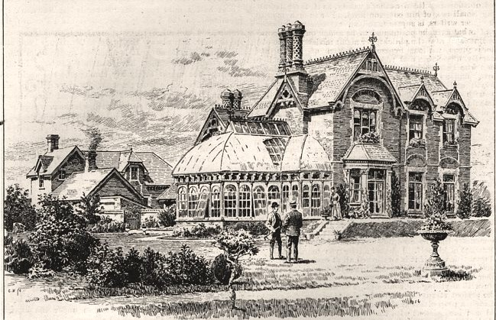
Falmouth House, Fred’s residence in Newmarket, since demolished.
A Shakespearean tragedy comes to mind as you learn of Fred’s final years; Helen gave birth to a boy named William in January 1884 who only survived a few hours. She remained seriously ill after the birth but recovered enough to fall pregnant again. That November everything changed for Fred. He rushed home overjoyed after winning the Autumn Cup at Liverpool, whilst there a telegram told him he was father to a healthy daughter and all was well but when he walked through the door that evening Fred “found the poor little woman writhing in convulsions, which continued until she died.” She was just 23 years old.
Despite his new baby girl named Nellie Rose bringing comfort (she was looked after by her grandparents), the grief was overwhelming and ultimately catastrophic. In less than a year Fred had lost his newborn son and heir and his beloved wife. He had already lost his older brother William Archer in a riding accident aged just 24 at Cheltenham in 1878.
He became depressed and even contemplated giving up riding altogether. Letters of sympathy poured in from all over the world but Fred remained in a melancholy stupor oblivious to those around him. “Once or twice he spoke of suicide” (Welcome, p152), something had to be done. This was a man who wasn’t used to losing, especially in the public eye.
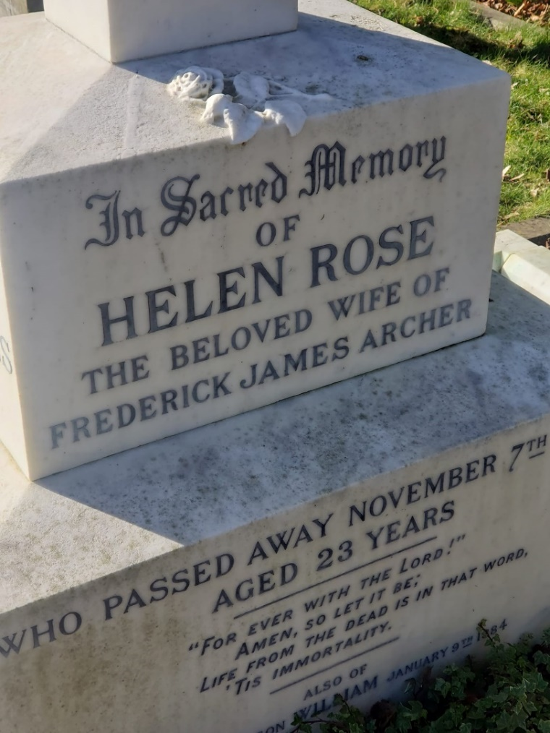
The Archer grave at Newmarket Cemetery.

Home Straight.
We all deal with grief in different ways; in the following year of 1885 Fred seemed determined to put his all into racing; a close friend took him to America for a change of scenery and he returned in better spirits and even put weight on, being nearly 10 stone. The self-destructive battle commenced once more.
Days turned to months and with every win his body was weakened until it finally broke in November 1886. That year he won the Derby, the July Stakes, the Great Yorkshire Stakes, the Champion Stakes, and the St Leger to name a few.
In the October of 1886 he raced in Ireland. Weighing 9 stone 4lbs, Fred spent a day in the Turkish bath and used his special mixture to drop to 8 stone 12lb so he was able to take a place in the Curragh in County Kildare which he won. Returning to England onboard a mail steamer Fred had a conversation with his ex-jockey turned starter friend Harry Custance:
“You don’t mean to say you are going to ride 8 stone 7lb next week?”
Fred answered he was “sure to ride…8 stone 6lb or at most 8 stone 7lb. I shall win the Cambridgeshire…” He was warned by Custance that “he had seen many jockeys who wasted on physic…at the back end of the season and go out like the snuff of a candle.”
Fred replied “never mind if I go out or not. I shall do it.” (Humphris, p245)
His tenacity failed him, Fred lost the race by a head. By the end of the month he caught a fatal chill; the wasting and physic was the only thing going to win this time.
In his bed at Falmouth House, Dr Wright diagnosed a “severe chill, followed by a high fever.” The next day (Sunday) it had turned to typhoid fever. Fred’s sister Emily was in attendance as well as a nurse. The serious nature of his illness was soon spread to family, friends and his racing associates who sent messages of gentle encouragement and hopes for a speedy recovery.
One of the complications of typhoid fever is the hallucinations and how it affects the mental health. Caused by a bacterial infection, it can attack all the body’s organs and is usually treated with antibiotics such as Ciprofloxacin, sadly for Fred they weren’t around until the early 20th century, penicillin only being discovered in 1928.

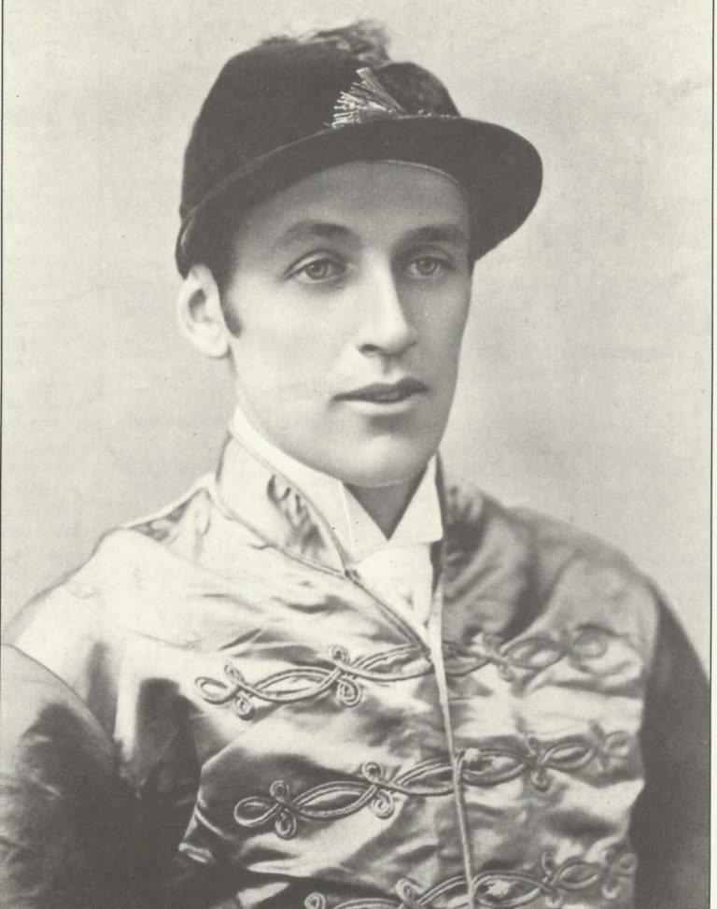
A handsome Fred in his jockey attire.
On the morning of Monday 8th November Fred appeared to be recovering and had spoken with a friend from his sick bed. In the afternoon, around 2pm, he sent his nurse out of the bedroom to speak with his sister in private. She recalls at the death inquest held the following day:
“When the nurse went out I was looking out of the window, and he said, ‘Are they coming?’ Almost immediately I heard a noise, and, looking round, saw that my brother was out of bed, and had something in his hand… I saw it was a revolver and tried to push it away.” (Humphris, p252)
A violent struggle occurred with Fred somehow finding strength to put one arm around Emily’s neck and fire the revolver into his mouth with his other hand. They both fell to the floor against the bedroom door; Emily screaming for help. Fred died immediately. Nobody knew a revolver was available to him in the room. It had been kept for security purposes as there had been several burglaries in the area. Infact it was gifted to Fred from racehorse owner Thomas Roughton several years earlier.
The cause of death on the certificate states:
“While in a state of temporary insanity induced by typhoid fever did kill himself by shooting himself with a revolver in the mouth and severing the spinal cord.”
Suicide was still a crime in England and Wales until 1961, if you managed to survive an attempt you could be punished with a prison sentence.
The fact it states he was not of a sound mind forgoes the criminal element. Dr Wright concurs this with his inquest evidence:
“He was not delirious in his fever, but disconnected in his thoughts. It seemed from the commencement to take a form of depression. I consider that in the weak state that he was in, followed by the fever, his brain was so disordered that he was not accountable for his actions…” (Humphris, p255)
The jury unanimously and very quickly returned a verdict of suicide “whilst in a state of unsound mind.”
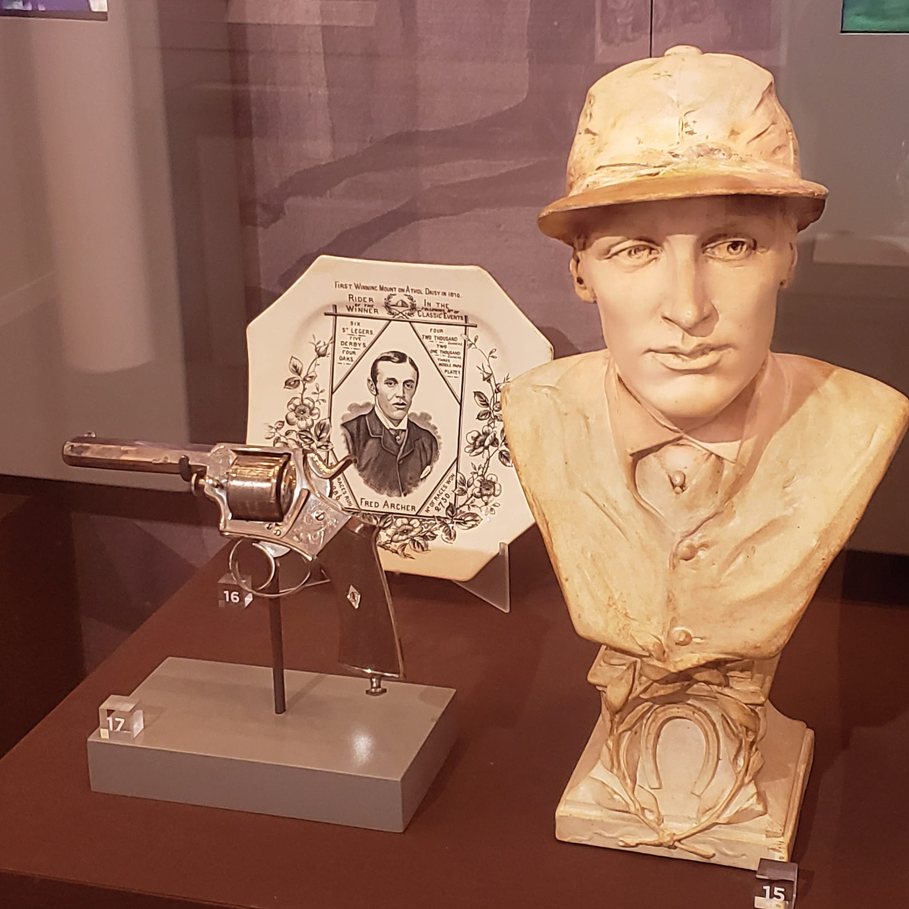 Archer related items including the revolver at the National Horseracing Museum in Newmarket. Note the same plate as held in the DANUM museum.

People all over the world were in shock at his death; the loss of potential to go even further in the racing world. Not to mention the disappointment for his numerous fans who placed regular bets on Fred.
How much of Fred’s constant and extreme weight loss methods contributed to his death? The depression caused by bereavement, the financial pressure to win races, his daily relentlessness to attain goals? Did he burn out so his physical body had no choice to but to give up the fight whether it was malnutrition, abuse from dehydration, or bacterial infections?
Fred has been the subject of several biographies, has a road named after him in Newmarket and the Fred Archer Stakes are run at Newmarket every summer. There are also living descendants through his daughter Nellie (1884-1931) who had four children with her husband.
Despite the many upsetting and disturbing episodes in Fred’s short life, I wish to turn the reader’s attention back to the ceramic plate that encapsulates his determination, successes, and unparalleled performance in his career. I believe Fred Archer was truly an incredible and triumphant sporting hero.
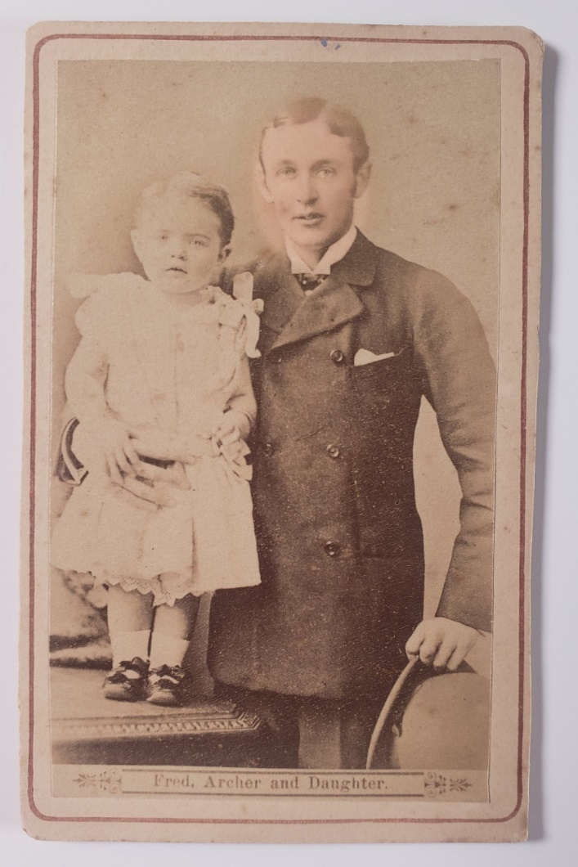
Fred with his daughter Nellie Archer.

Bibliography
- The History of the St Leger Stakes, J.S Fletcher, 1926. Hutchinson
- Modern Domestic Medicine, Thomas J. Graham, 1835. Simpkin and Marshall
- The Life of Fred Archer, E.M Humphris, 1923. Hutchinson
- Racing in Doncaster, Peter Tuffrey, 2009. The History Press
- Fred Archer His Life and Times, John Welcome, 1967. Faber and Faber
- Falmouth House, Newmarket. A Catalogue of Furniture and Numerous Effects to be Sold by Auction, printed 1887

